HTML kisi bhi website development ka backbone hai jisse ham basic structure banate hain apne website ka. HTML stands for Hyper Text Markup Language. Isskw Presentation Language bhi kehskte hain.
Hyper Text means any text or materials that has hyper-links. Hyper-links se ham websites main navigate krskte hain. Markup Language converts krta hai text kw different tables, images etc main.

HTML se ham webpage ka structure banate hain, CSS webpage ke presentation aur lay outing keliye hai. Aur Javascript webpage main interactivity add krta hai.

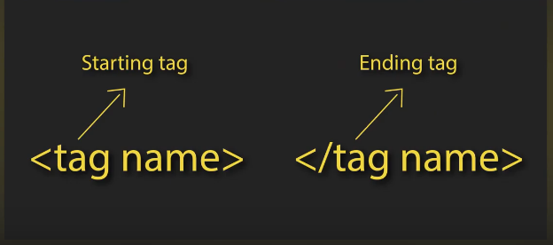

Dono tags ke beech main jw bhi content hwta hai woh element kehlata hai, and tags hamare browser kw btate hain keh content kw kis tarahse show krna hai.

<!DOCTYPYE html> is the first tag. Then <html> </html> ka tag aata hai jw root element hwta hai poore web page ka. In donon tags ke beech main hamara saara content store hwta hai. Then <head> and </head> ka tag aata hai jismain hamapne page ka title show krte hain.
Head ke tag ke baad <body> ka tag aata hai, jw document ke body kw represent krta hai i.e. jw bhi hamare site ka main and visible content hwga.
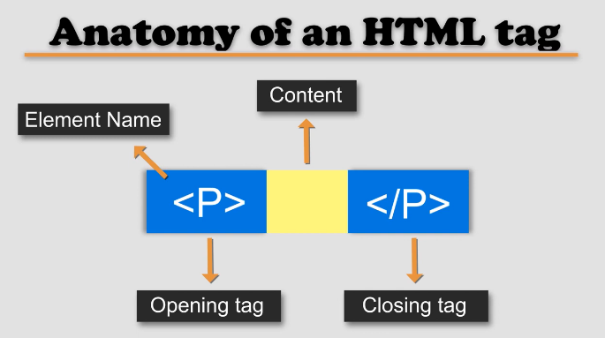
Here <p> is the tag for paragraph.
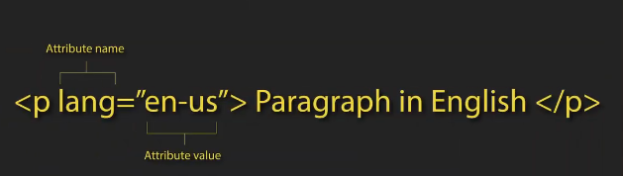

Attributes additional information dete hain hamare elements ke baare main. Aur ye name and value ke pair main hwta hai hamesha.

<!DOCTYPE html> browser kw btata hai keh ye ek html file hai.
<h1> hamare main heading hai.

Attributes hamesha opening tag main hnge, and consists of name and value pair, separated by equal sign and the value inside a double quote.

Attribute name btata hai keh ham kya additional information derae hain.
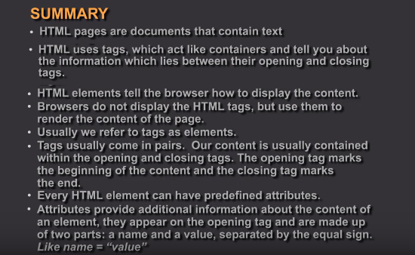
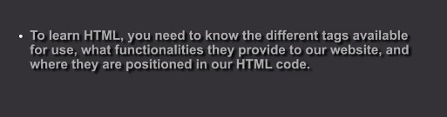
Do tarah ke markups hwte hain, ek structural markup and doosra and semantic markups(introduced in HTML5).

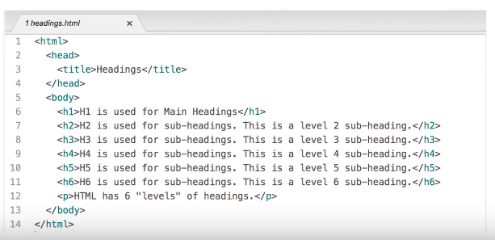
h1 is used for the largest headings and h6 is used for the smallest heading.
Har paragraph keh tag ka content new line main show hwga.

Agar kisi word kw bold krna hw tw ham <b> </b> ke tag se krenge. Similarly agar kisi word kw italic krna hw tw uskw <i> </i> se krenge.

<sup> </sup> se ham text kw superscript krskte hain. Similarly <sub> </sub> se ham text kw subscript krskte hain.

Whitespaces ham code-readability keliye dete hain. Browser line breaks and spaces kw ignore krdeta hai.

Agar paragraph ke darmian ham chahen ke line break hw, tw ham <br> ka tag use krte hai. <br> tag is a self closing tag or also an empty element.
Empty elements donot have any closing tag. <br> ke tag ke baad ka saara content web page new line pe show krega.

<hr> (horizontal rule) ka tag do topics ke darmiyan ek line gap dene keliye use hwta hai.

These all are structural markups

Semantic markups don’t affect the structure of the webpage, instead they are used by search engine and screen readers.

<strong> </strong>ka tag bhi word kw bold krdeta hai, lekin uske saath saath ye screen reader kw ye bhi btaega keh ye word important/highlighted hai.

<em> </em> ka tag word kw italicize krdega, but again ye screen readers kw bhi notify krdega keh ye word italicized hai.

<blockquote cite =” URL”> semantic tag hai jw screen reader and search engines kw btata hai keh ye line quote hai and ye URL wale website se liya hai. Quotations and any other content jw ham kahin aurse copy kren tw uska reference dena zroori hwta hai.

For shorter quotes ham <q> ka tag use krte hain jw quotes kw double quote main daal deta hai.
Agar kisi bhi word ka full form dikhana hw hamen HTML main tw <abbr title =”Full Term”> </abbr> ka tag use krte hain.

<address> </address>ke tag main page author ke details hwte hain e.g. physical address, phone number etc. Sb cheezen jw address ke tag main hwte hain who italicize hwjata hai.
<a href = “HYPER LINK”> </a>

<cite> </cite> ke tag main ham reference dete hain keh kahanse hamne koi cheez uthae hai.
<dfn> </dfn> screen readers and search engines kw btane keliye hwta hai keh ab jw cheez aaege woh kisi word ke definition hai. Ya phr jb ham koi new word kw first time explain kr rae hnge.

Out-dated information such as jb sale lage hwte hai tw pichle price strike through hwte hai, woh ham <s> </s> ke tag main dikhate hain.
Jbke agar hamen kuch replace krna hw tw ham <ins> </ins>and <del> </del> ke tags use krenge.
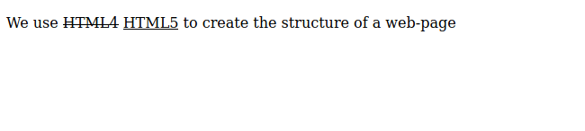
Ye ins and del use krke

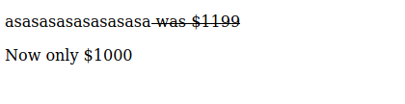
This is when we use <s> tag.

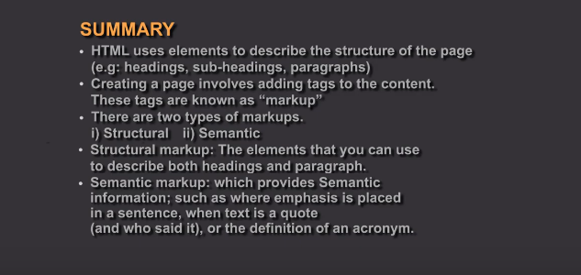

HTML main 4 tarah ke lists hwte hain:
- Ordered
- Unordered
- Nested
- Definition
Ordered list main order important hwta hai and har item numbered hwta hai, isska tag <ol> </ol>. e.g recipe etc.

Unordered list kw bulleted list bhi kehte hain aur isskw <ul> </ul> ke tag ke adar krte hain. Issmain order important nae hwta hai list ka.

Lists ke andar jw item hnge who <li> </li> ke tag ke saath likhenge.

Agar series of definition terms ya data show krna hw tw who ham definition list main krte hain, <dl> </dl>se uskw represent krte hain. <dl>
Ke andar items kw <dt> </dt> ke andar likhenge jaise list kw <li> ke andar likhte hain, aur <dd> </dd> ke andar <dt> wale term kw define krte hain.

Ek <dt> keliye multiple <dd> bhi hwskte hain. Aur isse tarah, multiple <dt> ke ek <dd> bhi hwskte hai i.e. multiple definition terms ke ek definition.

Ham ek list ke andar multiple ordered ya unordered list bana skte hain. Isskw nested list kehte hain.

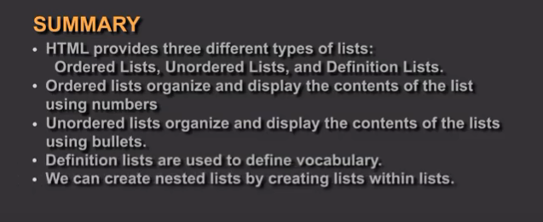

Links help us connect, navigate or jump from one webpage to another.
Hyperlinks keliye anchor ka tag hwta hai <a> </a>.

Anchor, relative URL and absolute URL se ham links kw define krskte hain. Anchor se ham ek he page ke andar navigate krte hain, relative URL se ham same website ke andar navigate krte hain and absolute URL se ham doosre websites pr navigate krskte hain.

Href ke through ham specify krte hain keh ye link kahan jaega. href attribute is used to define the target of the link. href attribute main ham relative and absolute dono URL use krskte hain.

<a href=”URL”> link text </a>

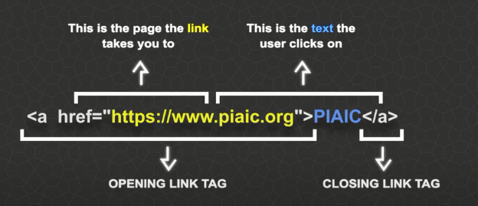
Link text hamara clear and relevant hwna chahiye, jisse pata chale keh ye link kahan lekr jaega. It also helps those who are using screen readers. Link text kw keywords rakhenge tw website jaldi rank hwge,
Absolute URL dete huwe hamen poora link daalna hwga i.e. https ke saath.

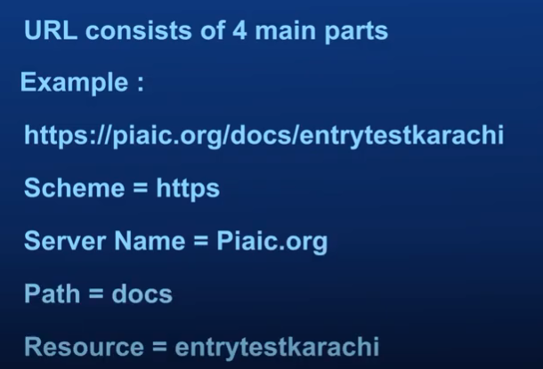

Absolute links are required for external links jismain domain name bhi diya gya hw (http or https).

Jb same he site main link krna hw tw poora URL nae denge, i.e. domain name ke zroorat nae hwte hai likhne ke. In links kw relative URL kehte hain.

Directory is defined as an organizational unit or container, used to organize folders and files to a heirchal structure.
Jb hamara code zyada bara hwjata hai tw uskw manageable krne keliye ham different sections kw alag alag folder/file main rakh dete hain, in folders kw ham directories kehte hain.

Top level folder jw hwta hai uskw root folder kehte hain jismain saare files waghaira hwte hain, har section kw alag folder main ham rakhte hain within the root folder jisse files organize hwjate hain.

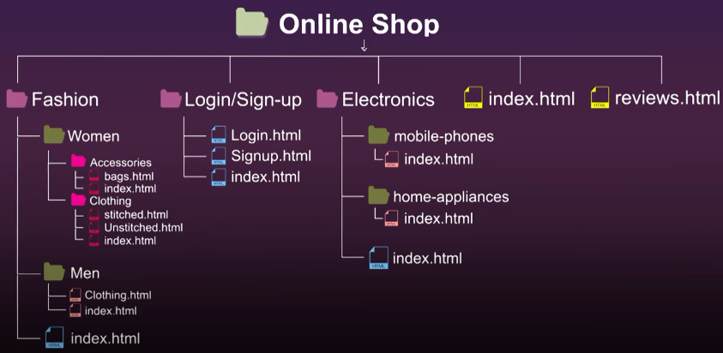

Issmain jw Online Shop ka jw folder hai who root/parent folder hai. Fashion, Login/Sign-up, index.html, review.html aur Electronics child elements hain Online Shop ke.
Then har folder ke apne child elements (grand-children of the root folder) and so on.
Relative URLs se ham sibling folders, child/ grand-child elements, parent/grand-parent elements kw access krskte hain.

Siblings kw access krne keliye ham srf sibling file name likh dete hain in the href attribute, agar child element kw access krna hai tw ham “folder/child element” likhenge href ke andar. Agar grand child access krna hwga tw ham folders likhte jaenge jis folder ke andar hwga i.e. poora path btaenge. “main-folder/sub-folder/grand-child element”.

Ek foldr bahar jane keliye ham “../” likhenge file name pr i.e. “../index.html” se ham current folder se nkal kr bahar wale folder main index.html kw access krenge.

Jtne folders se bahar nkalna hwga utne he ham “../” add krte jaenge file path main.

Agar email as a hyperlink hamen krna hw tw ham href ke attribute ke andar “mailto: email-address” likhenge.

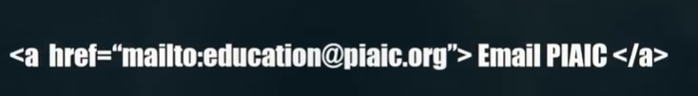

By default, hyperlinks same page main open hwte hain, lekin agar ham chahen keh hyperlink kw different page main kholen tw ham target ka attribute use krte hain. target="_blank"
se link new tab main khulaega and isskw ham href se pehle likhte hain.
Blank ke jaga self likhen ya target na likhen tw page same window main open hwga.

Ek he page main different sections main agar jump krna hw tw ham id attribute kw use krenge specify krne keliye keh ham kis part se kis part pr jump kr rae hain.
Ham har element kw id de skte hain jiske madadse ham quick navigation krskte hain within the web page i.e. ek paragraph kw maine AIC ke id de de, aur start of the page main Artificial Intelligence wale list item kw hyperlink krke AIC ke taraf point krdia, ab jab uspr click krenge tw who AIC ke paragraph main jump krjaega.

Id ya within same page jb navigation krne hwte hai tw ham href = “# id-name” use krte hain. # btata hai keh ham same page main navigate kr rae hain.

